**How to configure static routing.**

**## first configure pc1 ip address 192.168.10.2 255.255.255.0 and gateway 192.168.10.1**

**## second configure Router1**

**Conf t**

**Interface g0/0/1**

**Ip address 192.168.10.1 255.255.255.0**

**Description connected switch1**

**No shut**

**Int g0/0/0**

**Ip address 172.16.10.1 255.255.255.0**

**Description connected R2**

**No shut**

**## do the same configuration with other side using network 192.168.20.0 255.255.255.0 and 172.16.20.0 255.255.255.255.0.**

**## now you can configure static routing on Router2##**

**Enable**

**Conf t**

**Ip route 192.168.20.0 255.255.255.255.0 172.16.20.1**

**Ip route 192.168.10.0 255.255.255.0 172.168.10.1**

**## use command sow ip route to see routing table##**

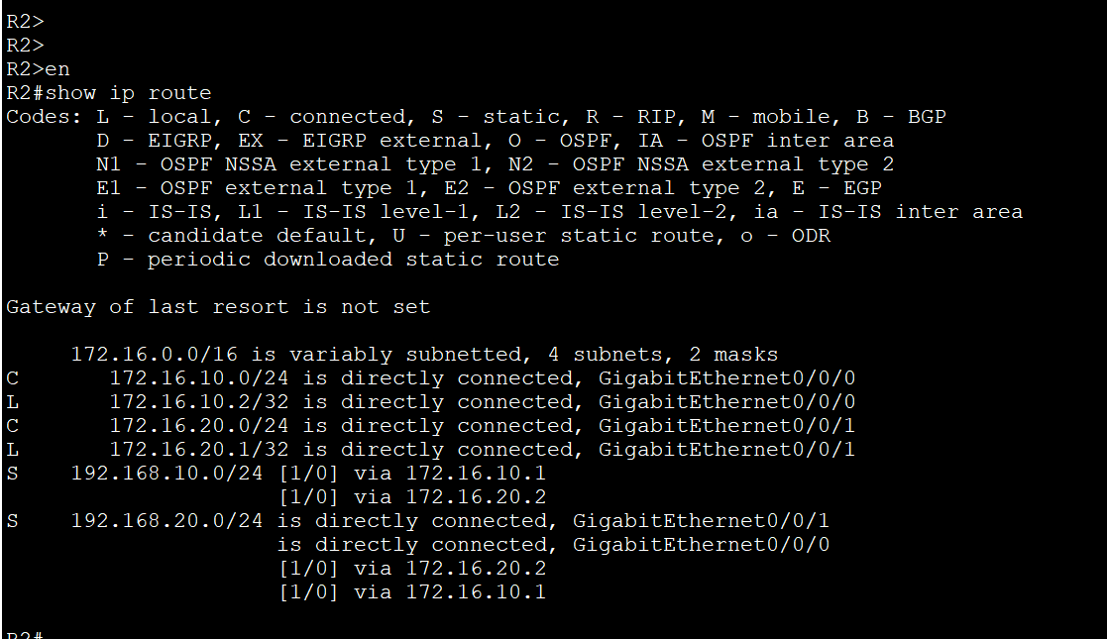

Ping pc1 to pc2 to test static routing protocol is working and now it is working



